* **Small Scale bussiness under 5000**



Popcorn machine

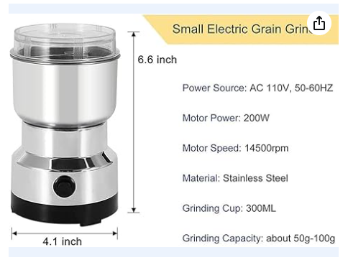

Chutney maker

* **Popcorn maker**
* Popcorn machine - 1200
* Chutney Maker - 600
* Outlet- type of popcorn and chutney

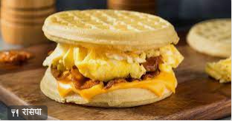

Waffle Sandwich

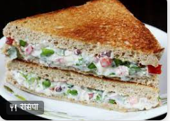

Bread Sandwich

* Example of grilled item
  + One item
  + One item
  + One item
  + One item
  + One item
  + One item
  + One item
  + One item
* **Sandwich & grilled item**
* Sandwich machine 3 in 1 electric- 3000
  + Or , Gas sandwich toaster - 500
  + Or , Induction sandwich toaster - 2200
* Slicer and greater - 300
* Outlet-
  + type of bread and waffle sandwich
  + Grilled item
* Example of bread sandwich Outlet
  + One item
  + One item
  + One item
  + One item
  + One item
  + One item
  + One item
  + One item
  + One item
* Example of waffles sandwich Outlet
  + One item
  + One item
  + One item
  + One item
  + One item
  + One item
  + One item
  + One item
  + One item
  + One item
  + One item
  + One item
* Example of grilled item
  + One item
  + One item
  + One item
  + One item
  + One item
  + One item
  + One item
* **Maggi item**
* Example of Maggi item
  + One item
  + One item
  + One item
  + One item
  + One item
  + One item
  + One item
* **Cake Bakery item**
* Cake making set - 1500
* Other ingredient - 500
* **Resell beauty product**
* **Sales Technique**